**SCS System User Manual**

1. **Introduction**

The SCS System is designed to help businesses manage their products, sales, purchases, and employee payroll in an organized manner. This document provides an easy-to-understand overview of how the system works without requiring programming knowledge.

1. **System Overview**

The system consists of three main sections:

* **Admin Management** – Allows administrators to manage user accounts and system settings.
* **Inventory Management** – Helps businesses keep track of products, sales, purchases, and vendors.
* **Payroll Management** – Manages employee salaries, attendance, benefits, and job roles.

Each section contains different features, which are explained at Section III.

**Button Functions Overview**

The system features various buttons with specific functions for navigation and operation:

* **Back Button (↩️)** – Returns to the previous screen.
* **Add New Record (📄➕)** – Opens a form to create a new entry.
* **Edit Record (✏️)** – Enables editing of existing records.
* **Save Record (💾)** – Saves changes made to a record.
* **Delete Record (🗑️)** – Removes the selected record from the system.
* **Print (🖨️)** – Generates a printable version of the document.
* **Export Data (📄➡️)** – Exports records in a predefined format.

**Login Function**

Before accessing the system, users must log in with their credentials. The login screen includes:

* **Username Field:** Enter your registered username.
* **Password Field:** Enter your secure password.
* **Login Button:** Click to authenticate and access the system.
* **User Role Authentication:** Determines user access levels (Administrator, Inventory, Payroll) and restricts access to specific modules accordingly.

Upon successful login, users will be directed to the system dashboard based on their role and permissions.

1. **System Features**
2. **Admin Module**

This module provides system administrators with access to user management and system settings.

**Managing Admin Functions**

* **User Profile Management:** Navigate to the **Profile** section, where administrators can update their information, change passwords, and manage authentication settings.
* **Registering Accounts:** Open the **Register Account** section, fill in user details, assign roles (Admin, Manager, Employee), and activate accounts.
* **Managing Inventory & Payroll Access:** The **Inventory** and **Payroll** tabs allow the admin to control access permissions, ensuring only authorized personnel can manage these modules.
* **System Configuration:** Modify system settings, including database connections, security protocols, and application preferences.

1. **Inventory Module**

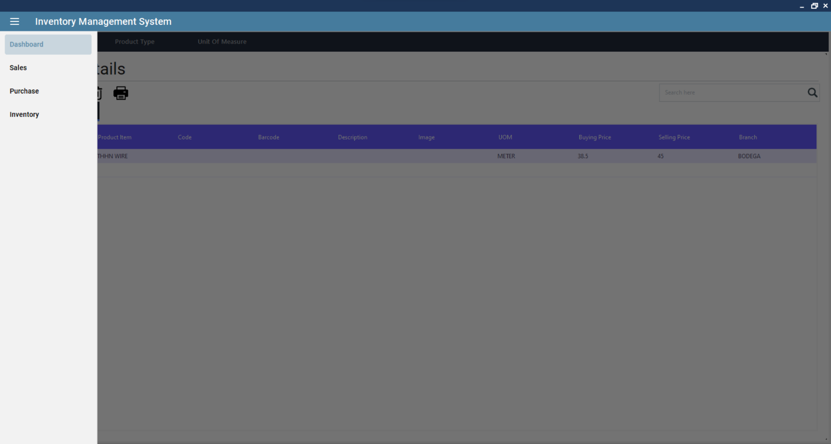

This module allows businesses to efficiently manage their inventory, including products, orders, vendors, and warehouses.

**Key Features and Their Functions**

1. **Billing System (Bill & Bill Type)**
   * Helps users generate bills for sales and purchases.
   * Categorizes bills based on type (e.g., purchase bills, sales bills).
2. **Branch Management (Branch)**
   * Keeps records of different store locations or company branches.
3. **Cash & Bank Management (CashBank)**
   * Tracks money transactions related to inventory purchases and sales.
4. **Customer Records (Customer & Customer Type)**
   * Stores details of customers.
   * Categorizes customers (e.g., wholesale, retail).
5. **Goods Received Notes (GoodsReceivedNote)**
   * Records when new stock arrives and updates inventory.
6. **Invoices (Invoice & Invoice Type)**
   * Helps generate invoices for sales transactions.
   * Categorizes invoices for better tracking.
7. **Numbering System (NumberSequence)**
   * Automatically assigns unique numbers to documents (e.g., invoices, orders).
8. **Payments (PaymentReceive & PaymentVoucher)**
   * Tracks payments received from customers.
   * Issues vouchers for payments.
9. **Product Management (Product & Product Type)**
   * Stores product details such as name, price, and stock levels.
   * Categorizes products (e.g., electronics, clothing).
10. **Purchase Orders** 
    * Helps businesses place and track purchase orders for new stock.
11. **Sales Orders**
    * Manages customer sales transactions.
12. **Shipment Tracking (Shipment & Shipment Type)**
    * Keeps records of shipped products.
    * Categorizes shipment types (e.g., local, international).
13. **Unit of Measurement (UnitOfMeasure)**
    * Helps standardize how products are measured (e.g., kilograms, liters).
14. **Vendor Management (Vendor & Vendor Type)**
    * Stores supplier details and categories them.
15. **Warehouse Management (Warehouse)**
    * Keeps track of where products are stored.
16. **Payroll Module**

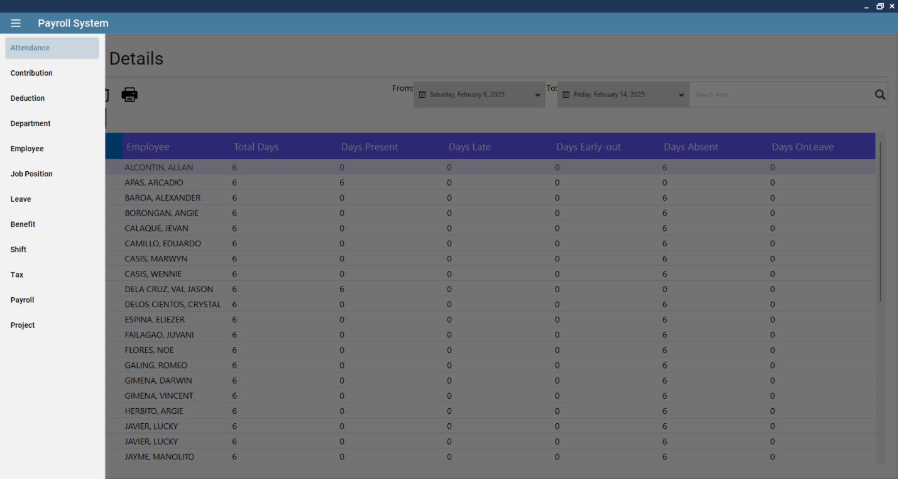

This module manages employee-related tasks such as attendance, salaries, and benefits.

**Key Features and Their Functions**

1. **Allowances (Allowance)**
   * Manages extra payments given to employees (e.g., travel allowance, meal allowance).
2. **Attendance Tracking (Attendance)**
   * Keeps records of employee work hours and attendance.
3. **Employee Benefits (Benefit)**
   * Tracks employee benefits such as health insurance and bonuses.
4. **Bonus Management (Bonus)**
   * Records additional payments given to employees based on performance.
5. **Contributions (Contribution)**
   * Keeps track of employee contributions to funds such as pensions.
6. **Salary Deductions (Deduction)**
   * Manages deductions such as tax or loan repayments from employee salaries.
7. **Department Management (Department)**
   * Organizes employees into different departments (e.g., sales, marketing).
8. **Employee Records (Employee)**
   * Stores employee details such as name, role, salary, and personal information.
9. **Job Positions (JobPosition)**
   * Defines job roles within the organization.
10. **Leave Management (Leave)**
    * Tracks employee leave requests and approvals.
11. **Performance Reviews (PerformanceReview)**
    * Stores employee performance evaluation details.
12. **Project Management (Project)**
    * Links employees to different projects they are working on.
13. **Shift Scheduling (Shift)**
    * Manages employee shifts and work hours.
14. **Tax Management (Tax)**
    * Tracks tax deductions and ensures compliance with regulations.

**How to Use the System**

**Managing Inventory**

* **Adding Products:** Navigate to the **Product** section, click on **Add New Record**, and fill in the details such as name, category, price, and stock quantity. Click **Save** to store the information. Use the search bar to find a specific product and the edit button to modify details.
* **Creating Sales Orders:** Open the **Sales Order** section, click on **Add New Record**, enter customer details, select products, and confirm the order. The system will generate an order summary. Users can view, edit, or delete sales orders as needed.dd taxes, and email invoices directly to customers.
* **Tracking Shipments:** Use the **Shipment** feature to log delivery details, assign tracking numbers, and update shipment statuses. Filters are available to check deliveries by date range or order status.
* **Managing Vendors:** Navigate to the **Vendor** section, add new vendor details, categorize them, and track their purchase history. Vendor information can be edited and viewed in reports.

**Managing Payroll**

* **Adding Employees:** Go to the **Employee** section, click on **Add Employee**, and input details such as name, department, position, and salary. Users can update employee profiles and attach relevant documents.
* **Tracking Attendance:** Navigate to the **Attendance** section where employees’ daily work hours are displayed. Use the date filter to specify a date range.

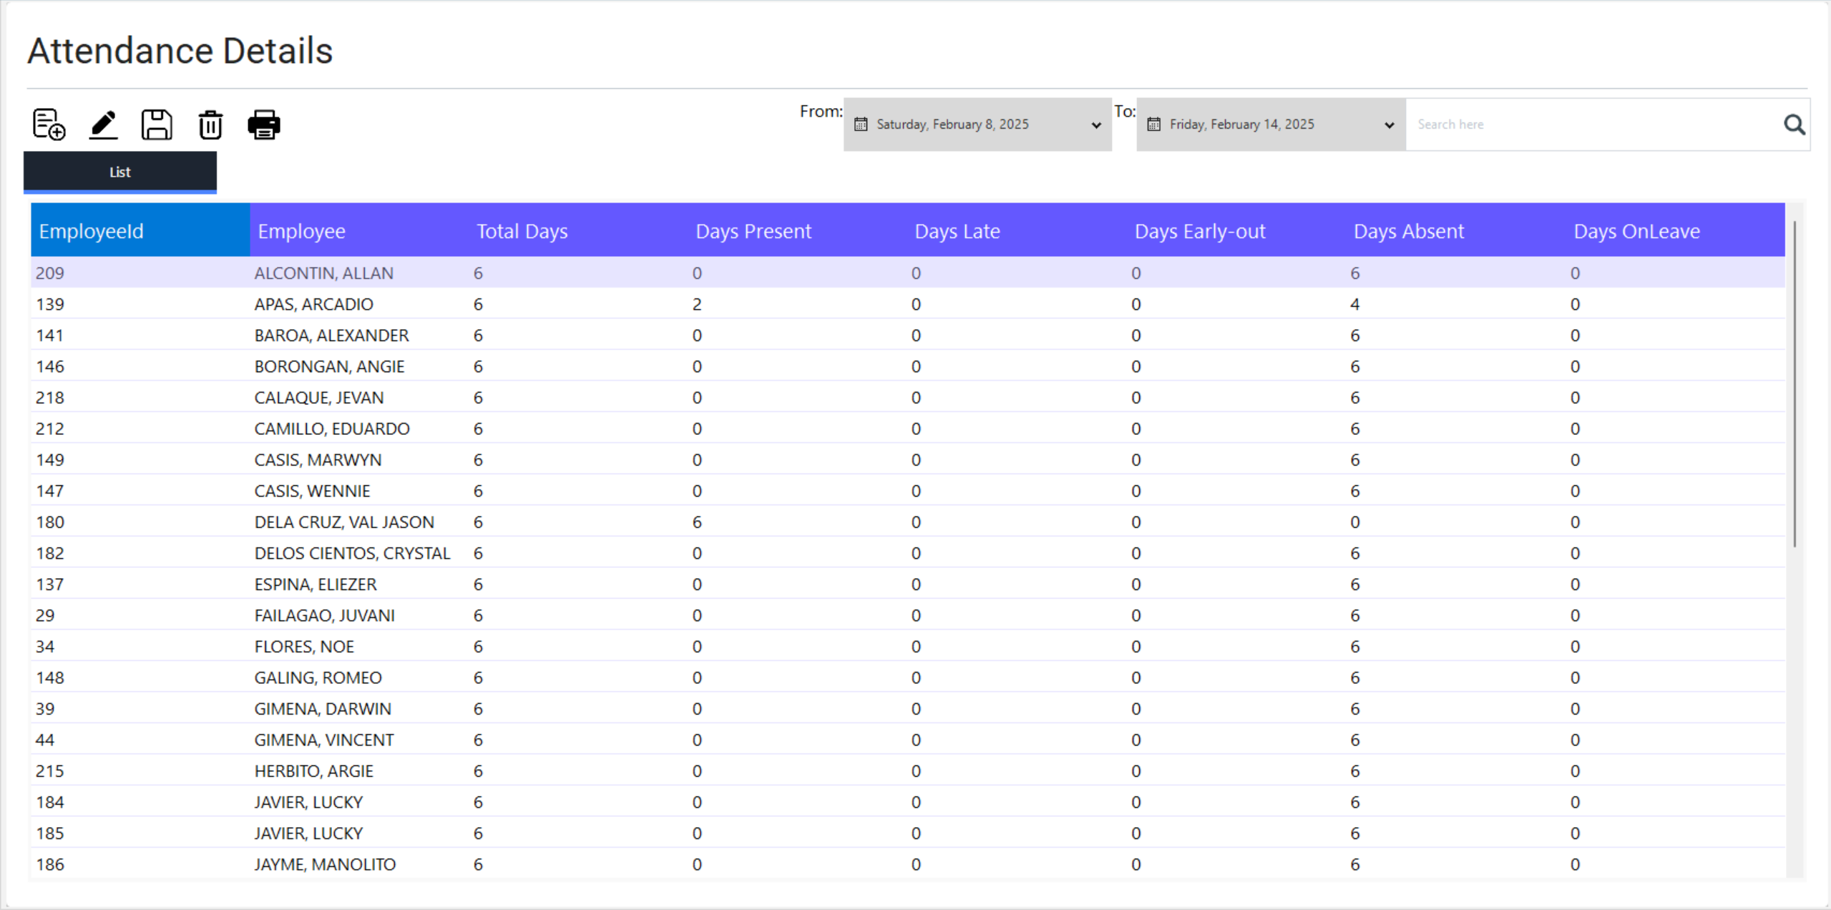

Double click on a record to review attendance details. To edit individual attendance, you have to click the generated individual employee attendance summary and select the entry and press edit **Edit**.

If needed, manually adjust work hours, entering the correct hours, and saving the changes. The system also allows searching for a specific employee’s attendance using the search bar.

* **Processing Salaries:** Use the **Deduction** and **Tax** sections to apply necessary deductions and calculate net salaries before payroll processing. The system provides salary slip generation and payroll export options.
* **Payroll Generation:** Navigate to the **Payroll** section, where users can generate payroll reports for a specific pay period. Select the employee group, verify salary components, and finalize payroll. The system allows generating payslips and exporting payroll data for further processing. Click the individual employee payroll generated on the list to generate a payslip.
* **Approving Leaves:** Review leave requests in the **Leave** section, approve or reject applications, and track employee leave history. Filters can be applied to view leaves by department or employee status.